**Spain Temperatures Dataset**

<https://developers.google.com/earth-engine/datasets/catalog/ECMWF_ERA5_MONTHLY#description>

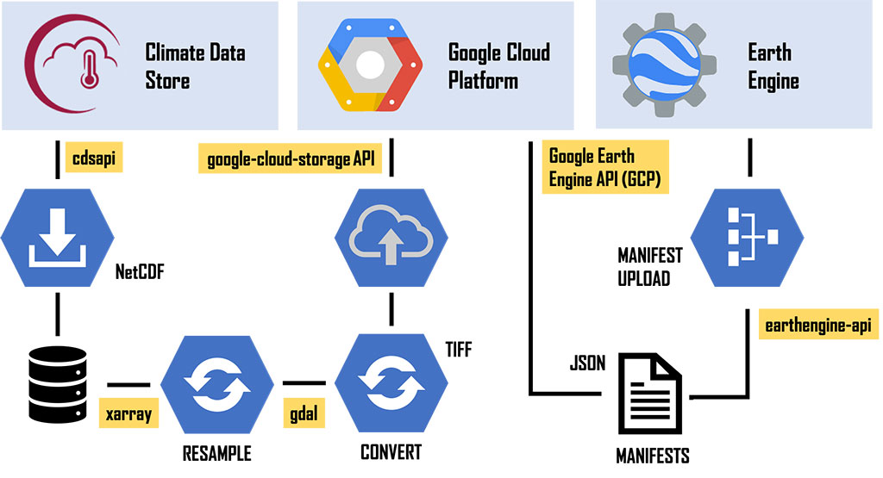

https://www.ecmwf.int/en/newsletter/162/news/era5-reanalysis-data-available-earth-engine

uses ‘Copernicus’ satellite

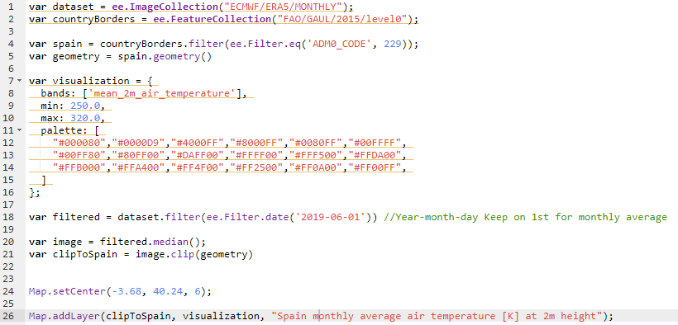

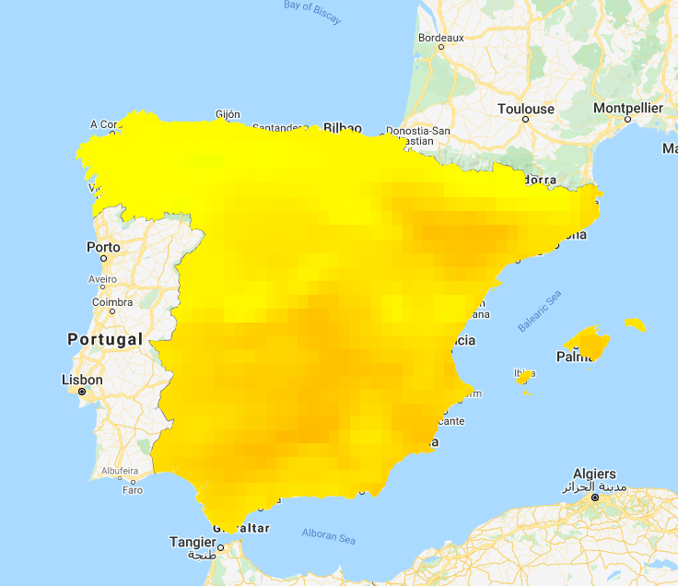

Dataset of country borders:

<https://developers.google.com/earth-engine/datasets/catalog/FAO_GAUL_2015_level0?hl=en#table-schema>

**Possible permafrost dataset:**

<https://catalogue.ceda.ac.uk/uuid/6e2091cb0c8b4106921b63cd5357c97c>

<https://nsidc.org/support/how/how-convert-golive-netcdf-variables-geotiff>

<https://developers.google.com/earth-engine/guides/image_upload>

This isn’t published but could be really useful - https://catalogue.ceda.ac.uk/uuid/8239d5f6263f4551bf2bd100d3ecbead

What I’ve done:

* Install cobra to then install gdal
* 
* 
* 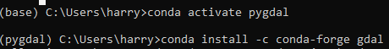
* 
* 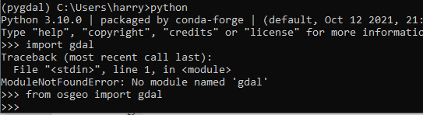

Translate .nc into geotiff

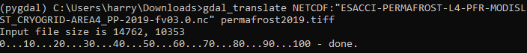

Problem uploading to google earth engine

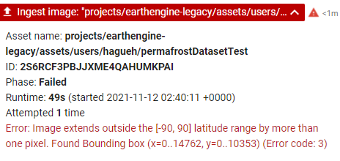

=COUNTIF(1:10353,<=14)

=COUNTIFS(1:10353,">=10", 1:10353,"<50")

=COUNTIF(1:10353,<=14)

=COUNTIF(1:10353,100)

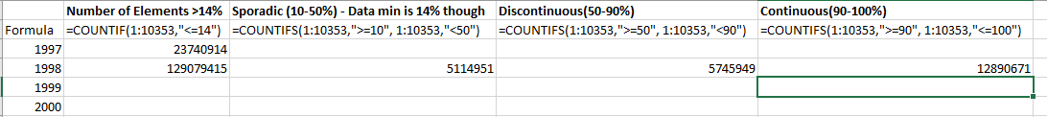

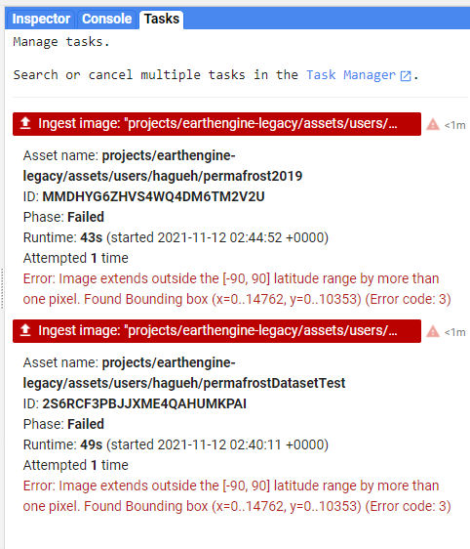

Use Cross Validation

<https://www.youtube.com/watch?v=fSytzGwwBVw>

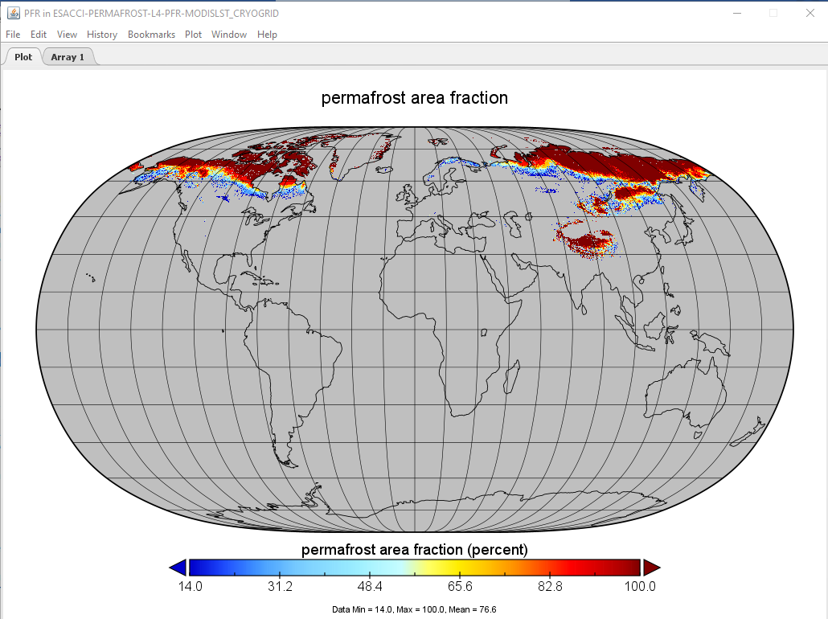

ESA Permafrost Climate Change Initiative Project 2019 Dataset

Issue is all the data is annual

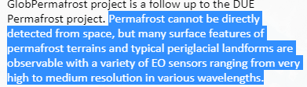

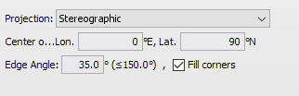

Good View settings ponoply

<https://gtnp.arcticportal.org/data/database-management-system>

Dataset with monthly values but only for Alaska, based of boreholes

<https://apgc.awi.de/dataset/near-surface-conditions-synthesis-1997-2016-alaska>

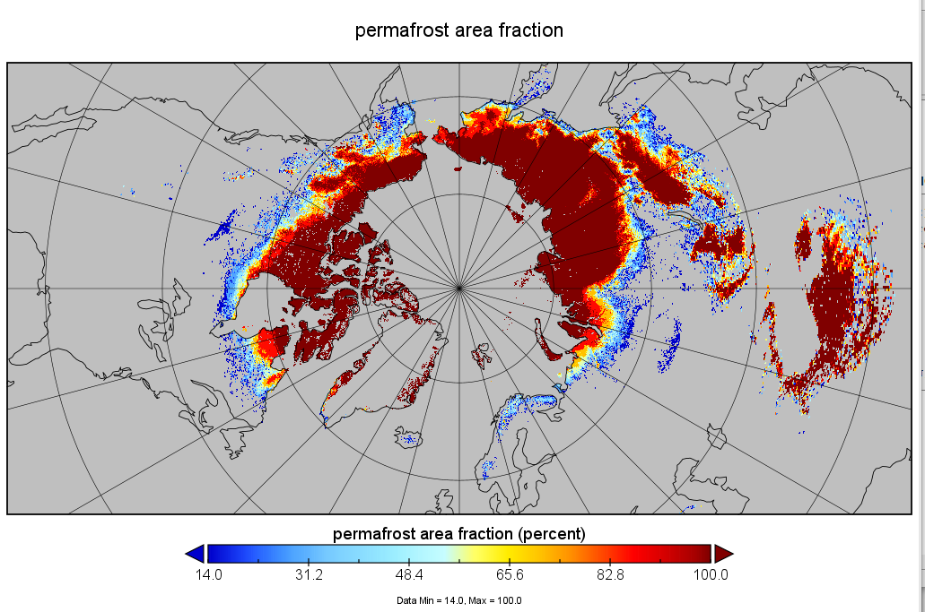

Useful GEE Code: <https://gis.stackexchange.com/questions/347526/calculating-annual-mean-temperature-from-era5-data-in-earth-engine>

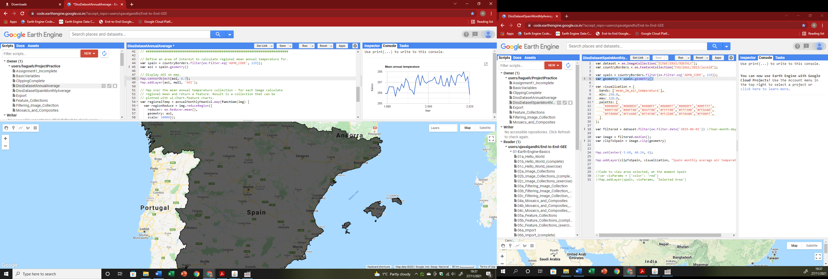Spain annual temperatures with graph

Problem with size

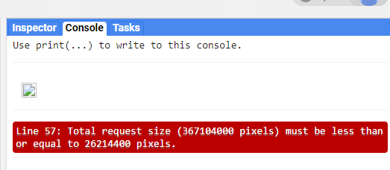

Start of visualisation. Graph works but data needs to be limited to years where there is also permafrost data. Visualisation a bit broken

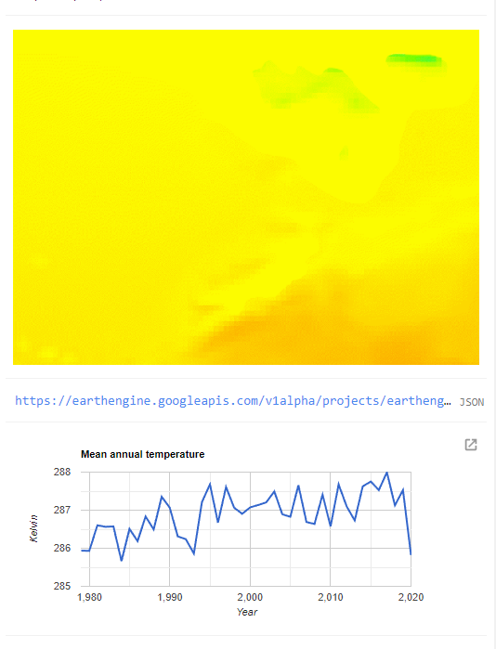

Progress Made: Now have a graph and animation of Spain annual average 2m air temperature

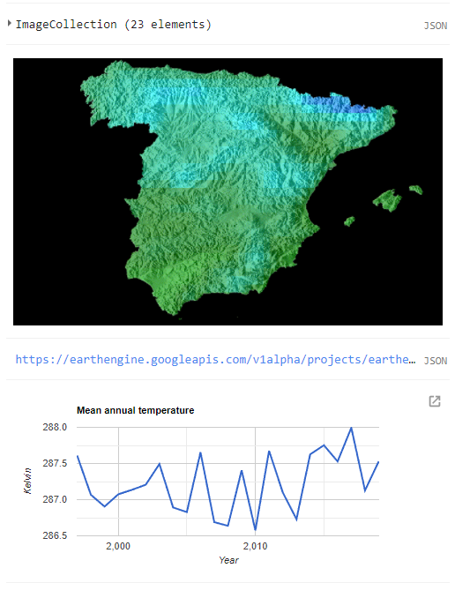

Created Permafrost animation from ESA data

<https://opendata.aemet.es/centrodedescargas/productosAEMET>?

AEMET dataset, has climate predictions which could be useful for write up as well

Note: ta_max = max temperature

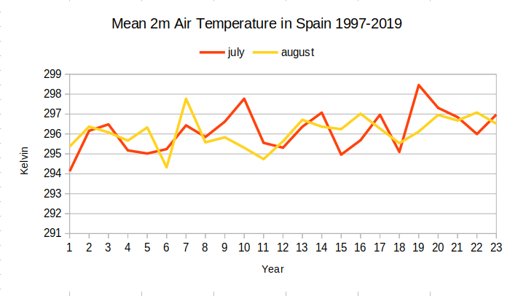

Permafrost Useful!!

<https://climate.esa.int/en/odp/#/project/permafrost>

<https://www.esa.int/Applications/Observing_the_Earth/Space_for_our_climate/Long-term_permafrost_record_details_Arctic_thaw>

<https://www.nature.com/articles/s41598-019-39942-4>

Historical Permafrost Changes:

<https://agupubs.onlinelibrary.wiley.com/doi/full/10.1002/2017JD027691>

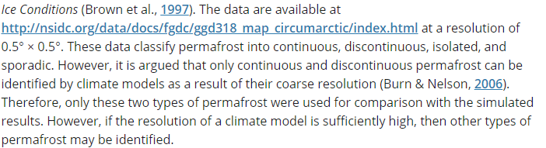

For 2019 data, might want to check older data is same spatial resolution



Saying the ESA CCI is good:

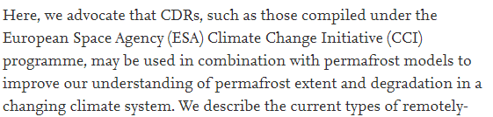

<https://www.sciencedirect.com/science/article/pii/S0034425717302201?via%3Dihub>

Snippets from remotesensing:

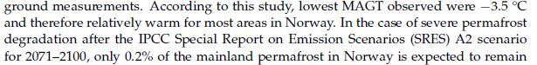

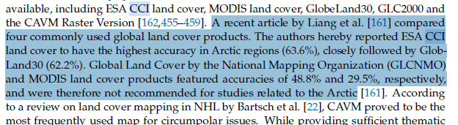

From: https://www.nationalgeographic.com/science/article/arctic-thawing-ground-releasing-shocking-amount-dangerous-gases

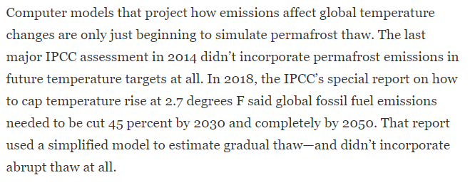

From: https://www.researchgate.net/publication/303722386_Remote_sensing_of_permafrost_and_frozen_ground

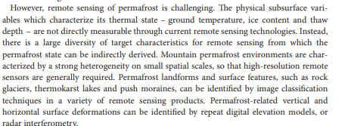

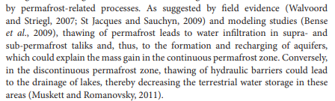

IPCC 2020 Report Card highlights:  
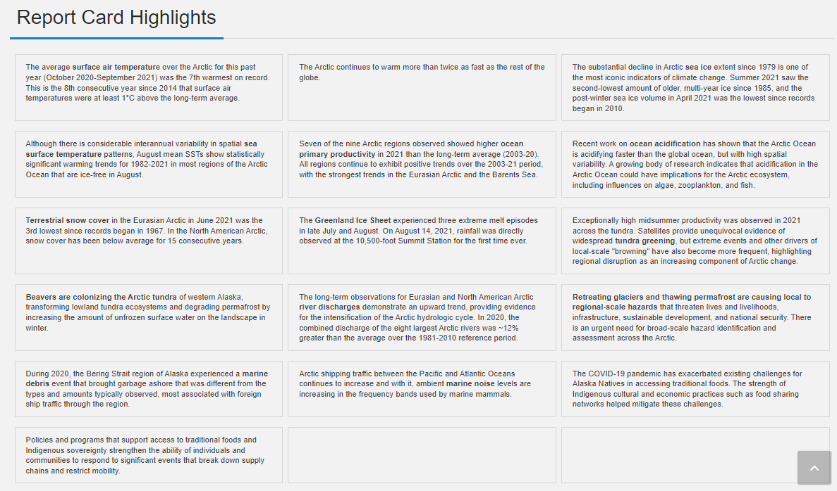

Spain temp data 1979 – 2019:  
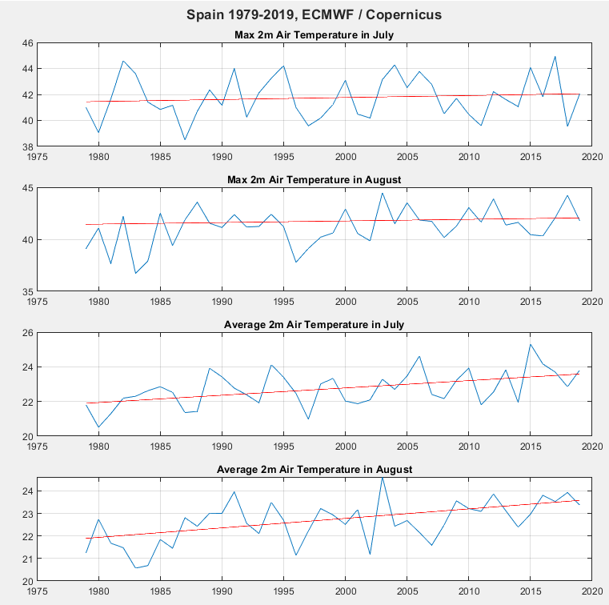

Spain Temperature data 1997-2019:  
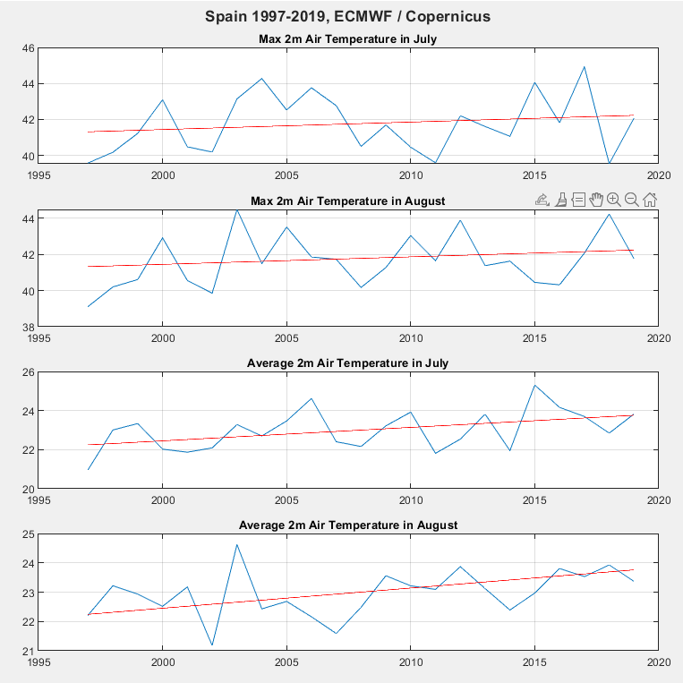

**EQUATIONS:**

Y = a + b/x + c*log(x)

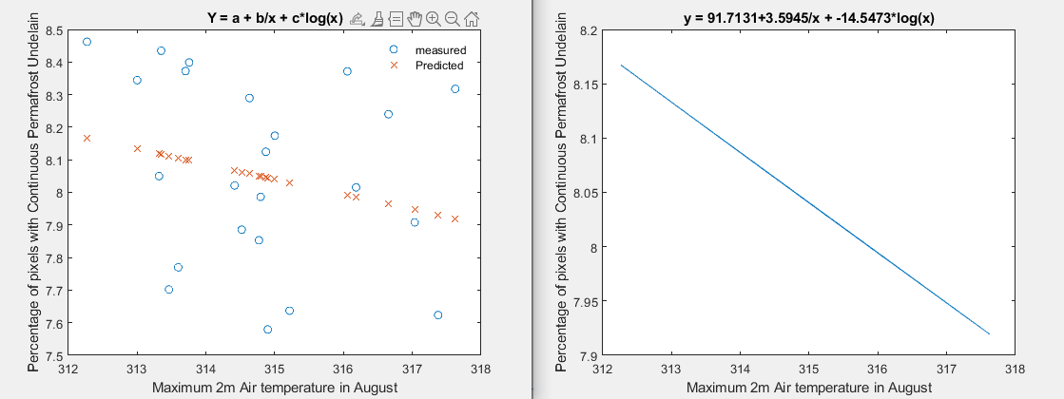

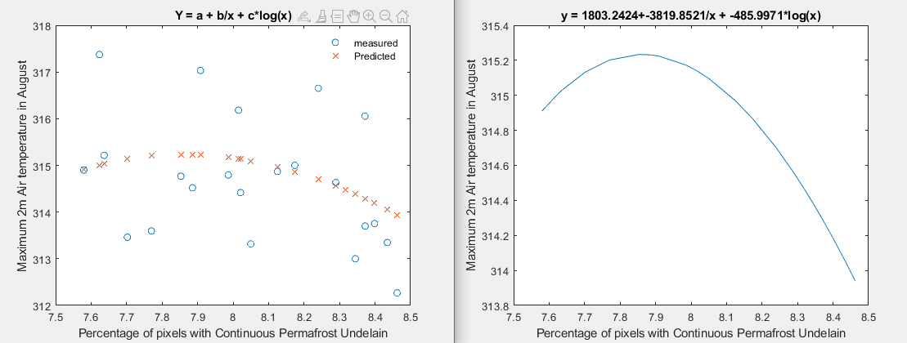

**CRUCIAL on ESA CCI DATASET:**<https://climate.esa.int/media/documents/CCI_PERMA_PUG_v3.0.pdf>

**New dataset info:**

The Land Surface Temperature (LST) products and services identified by users for the pan-Arctic (25 km resolution) scales include weekly and monthly averages from 2000 to 2010 from which annual averages can also be calculated. The LST processing integrates the LST level 2 products from MODIS and AATSR distributed by NASA and ESA, respectively. Post-processing functions supply University Waterloo-level-3 weekly and monthly LST products for regional (1 km) and pan-Arctic (25 km) scales. Thepan-Arctic product, with a spatial resolution of 25 km, is produced by spatial averaging of 1-km observations.

MOD11_L2 and MYD11_L2 LST (Version 5 from NASA Terra and Aqua satellites) and ATS_NR_2P (from ESA Envisat satellite) products at 1 km resolution are used as input data to generate pan-Arctic and regional products. The original geo-located LST observations are characterized by an irregular distribution based on the satellite orbits. The Northern Hemisphere EASE-Grid Lambert Equal Area Azimuthal projection with a sphere datum (with a radius of 6371.228 km) was selected as the standard projection for the operational pan-Arctic and regional products. Original MODIS and AATSR LST level 2 observations are projected using the EASE-Grid coordinate system and interpolated to a regular EASE-Grid with 1 km spacing using triangulation. The EASE-Grid projection was chosen since this is the system adopted by the GlobSnow project and for most snow and ice products distributed by NSIDC. Local time is calculated using UTC acquisition time and longitude. UTC is extracted from ADS information for AATSR data and from the file name of MODIS level 2 (Terra and Aqua) products, yielding a temporal accuracy of Â± 15 minutes, which is found to be sufficient for weekly and monthly products.

Temporal aggregation is applied to both 1 km and 25 km data to produce weekly and monthly LST averages. Interpolated LST observations on a 1 km grid (regional product) and 25 km (pan-Arctic product) are aggregated into two bins; a day-time bin (from 6 a.m. to 6 p.m. local time) and a night-time bin (6 p.m. to 6 a.m. of the next day) within the aggregation period (week or month). The definition of day and night does not take in account the notion of polar darkness and does not consider the seasonal changes of day length. It was defined to force final products to have an equal number of observations around the day. A mid range average is calculated by taking the day-time and night-time average to avoid daily diurnal fluctuations during the week or month of interest.

Known issues: the LST data are all measured during clear-sky conditions. The influence of clouds on surface temperature (e.g. temperature warmer under clouds in winter) is not reflected in the LSTs. This makes the LST colder than in reality due to the isolative effect of clouds.

|  |
| --- |
| Each LST file contains 6 bands: the datafiles 001 to 006, bands 001, 003, 005 are the LST averages and bands 002, 004, 006 are supplementary quality information: |
| Bands with averages of LST: |
| 001 - Weekly or monthly aggregated average LST product based on equal weight of average day-time (003) and  night-time (005) LST values. |
| 003 - Average day-time weekly or monthly LST based on all cloud free observations falling during 6 a.m. to 6 p.m.  local time. |
| 005 - Average night-time weekly or monthly LST based on all cloud free observations falling into each pixel cell  during 6 p.m. to 6 a.m. local time. |
| Supplementary information bands: |
| 002 - Number of LST cloud free observations falling into each pixel for the aggregation (weekly or monthly) period.  Associated with LST file 001. |
| 004 - Number of LST cloud free observations during day-time (6 a.m. to 6 p.m. local time) falling into each pixel.  Associated with LST file 003. |
| 006 - Number of LST cloud free observations during night-time (6 p.m. to 6 a.m. local time) falling into each pixel.  Associated with LST file 005. |
| See hdl:10013/epic.38768.d012 for an overview figure. The product guide: hdl:10013/epic.38768.d011. |
| This dataset is part of the ESA Data User Element (DUE) Permafrost Full Product Set  (doi:10.1594/PANGAEA.780111). |

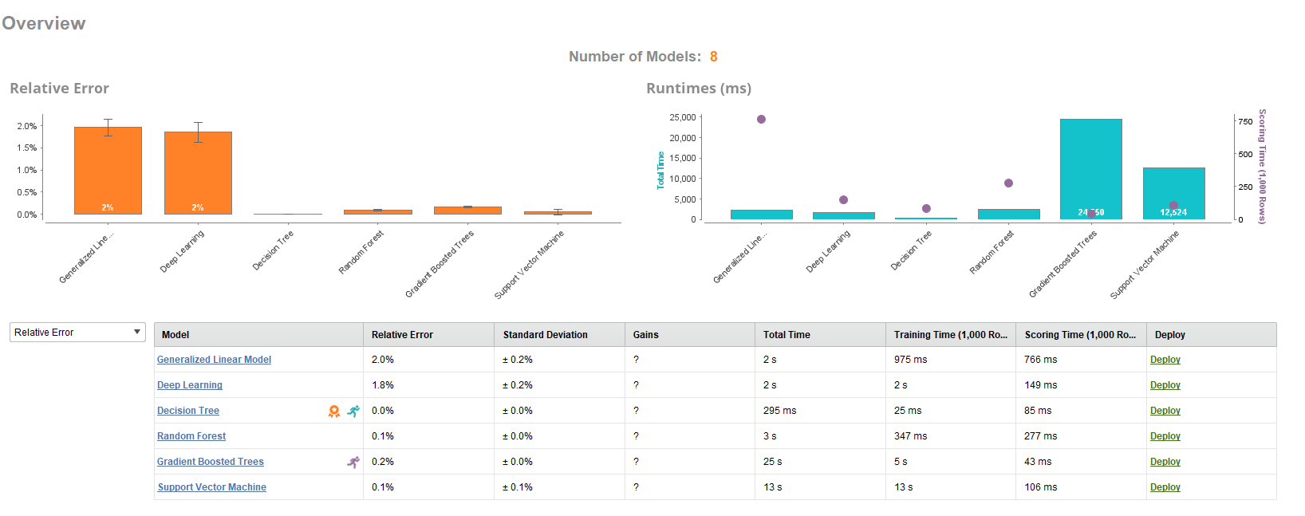

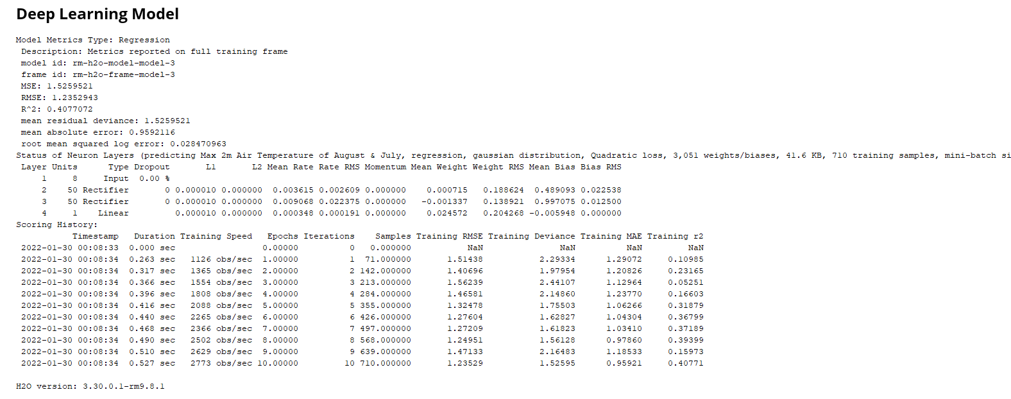

mniBatch size: 1

**Expansion of sahara, shrinking ice paper:**

<https://www.nature.com/articles/s41598-020-61085-0>

**Diagram Explanation:**

Reference: <https://geo.libretexts.org/Courses/Gettysburg_College/Book%3A_An_Introduction_to_Geology_(Johnson_Affolter_Inkenbrandt_and_Mosher)/13%3A_Deserts/13.02%3A_The_Origin_of_Deserts>

Atmospheric circulation and geographic location are the primary causal agents of deserts.  There are three generalized circulating cells of rising and sinking air called the **Hadley Cell**, the **Ferrel** or **Midlatitude Cell**, and the **Polar Cell**. Solar energy falling on the equatorial belt heats the air and causes it to rise. The rising air cools and its contained moisture falls back on the tropics as rain. The drier air then continues to spread toward the north and south where it collides with the Ferrel Cell and they sink back at about 30 degrees north and south latitudes. This sinking drier air creates belts of predominant high pressure along which desert conditions prevail in what are called the “horse latitudes.” These belts of predominantly high pressure have air that descends along these belts and flows either north to become the westerlies or south to become the trade winds. These circulation cells in the atmosphere rising in the tropics and polar regions and sinking in the horse latitudes produce the desert belts along the horse latitudes at approximately 30 degrees north and south of the equator [[2](https://geo.libretexts.org/Bookshelves/Geology/Book%3A_An_Introduction_to_Geology_(Johnson_Affolter_Inkenbrandt_and_Mosher)/13%3A_Deserts/13.02%3A_The_Origin_of_Deserts#2)].

Hot Rising air of the ferrel cell is taking longer to cool as the polar cells go more south, so the air is warmer when going over spain it’s warming quicker on its way back. When polar jet moves down it brings low pressure to desert regions near 30°, this is the main. But not only, cause of precipitation in mid-lattitudes. If it’s moving more north, less low pressure to spain.

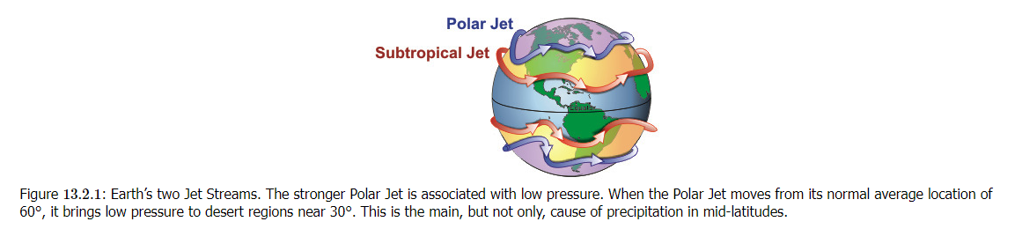

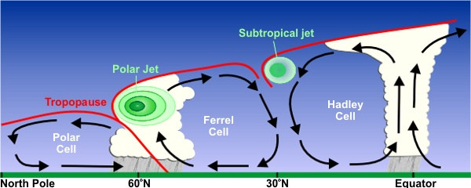

Reference: https://www.climatesignals.org/climate-signals/hadley-cell-expansion#more

The key concern is that widening of the Hadley circulation would cause a poleward shift of the subtropical dry zone (which is located where air in the Hadley cell descends). This could lead to regional rainfall reductions and the drying of subtropical landmasses,

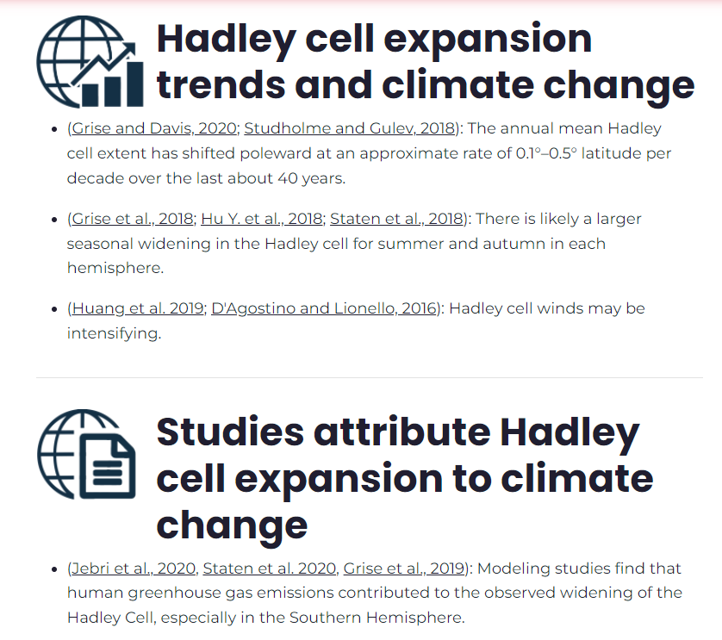

Effects can be localised:

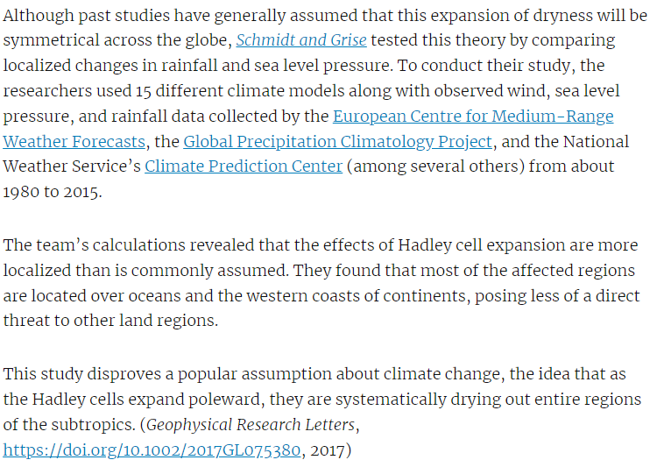

GOLDEN! Reference: https://www.researchgate.net/publication/264902638_Poleward_expansion_of_Hadley_cells

A decrease in the pole-to-equator temperature gradient in the model leads to an expansion and slowing of the Hadley circulation as well as a poleward movement of jet streams, thus suggesting a simple mechanism for these observed climate changes.

Spain Desertification: 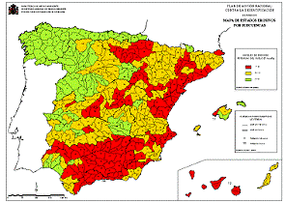

Spain is the most worrying example: according to the National action programs (NAPs) for the United Nations Convention to Combat Desertification (UNCCD) about 74% of Spain is at risk of desertification and 18% at high risk of becoming irreversibly desert.

How to explain hidden factors:   
On Earth, the temperature distribution at the surface isaffected by many factors in addition to solar influx, such as differencesin the surface albedo, greenhouse gases and the ocean transport of heatfrom the tropics to poles. In the model these factors are modeled col-lectively by changes in the parameters ∆T and Tr. It is expected thatchanges in the manner in which the differential heating is applied wouldnot change the qualitative dynamics, as is the case for differentiallyheated rotating fluids in cylindrical annuli [21].   
*(PDF) Poleward expansion of Hadley cells*. Available from: <https://www.researchgate.net/publication/264902638_Poleward_expansion_of_Hadley_cells> [accessed Feb 23 2022].

Maths Reference, GOLDEN authors: https://www.researchgate.net/publication/220403001_Hysteresis_in_a_Rotating_Differentially_Heated_Spherical_Shell_of_Boussinesq_Fluid

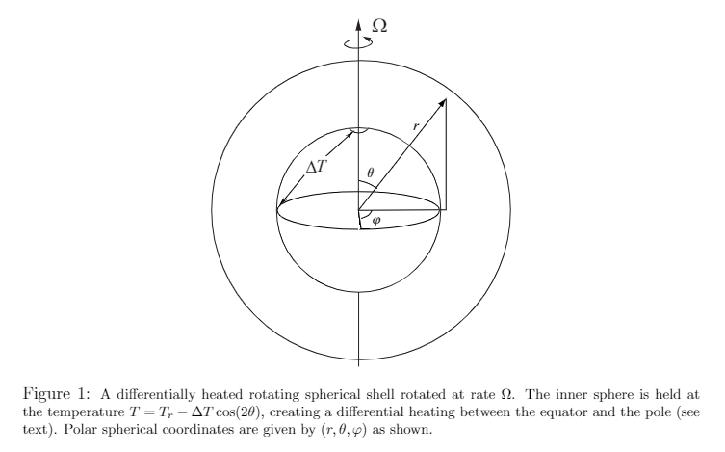

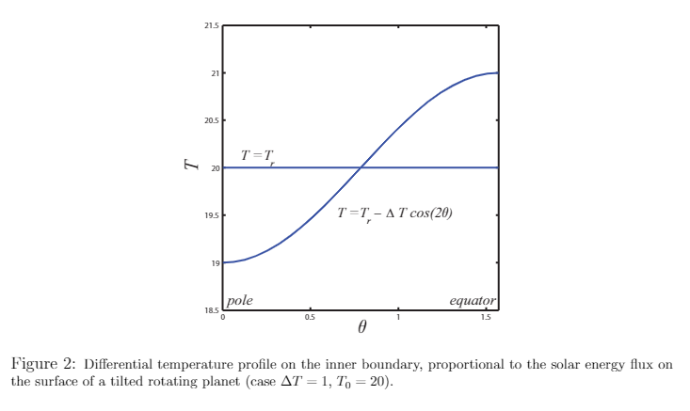

However, for even very small ∆T > 0, the fluid immediately begins to flowin a large stable convection cell with easterly flow toward the equator near the inner surface,similar to a Hadley cell except that it extends from equator to pole (in each hemisphere).In this paper, we refer to this as the Hadley cell. For larger values of ∆T, two or eventhree convection cells may appear between the equator and pole. The Hadley cell shrinks,always keeping one edge at the equator, while the additional cells appear between it andthe pole. When a second cell exists next to the Hadley cell, it is characterized by a weakercounter-rotating flow, with a westerly component. The third cell, when it exists, has thesame rotation as the Hadley cell but lies near the pole. In every case, there is a region ofhigh velocity azimuthal flow at high altitudes and mid-latitudes, resembling the Earth’s jetstream.   
*(PDF) Hysteresis in a Rotating Differentially Heated Spherical Shell of Boussinesq Fluid*. Available from: <https://www.researchgate.net/publication/220403001_Hysteresis_in_a_Rotating_Differentially_Heated_Spherical_Shell_of_Boussinesq_Fluid> [accessed Feb 23 2022].

From: https://curry.eas.gatech.edu/Courses/6140/ency/Chapter11/Ency_Atmos/Permafrost.pdf

